Blending Photos to create a new design (picture)
For this assignment, you will need to find five or six images of different textures and values. You will then layer them in Photoshop and play with arrangements and blending modes to create different pictures. Your result will be at least 6 different pictures (that all use the same images). Below are my examples, they each use the same 5 images but in different orders and using different blending modes. You may also get rid of some areas in each picture, scale each up or down, and repeat images.

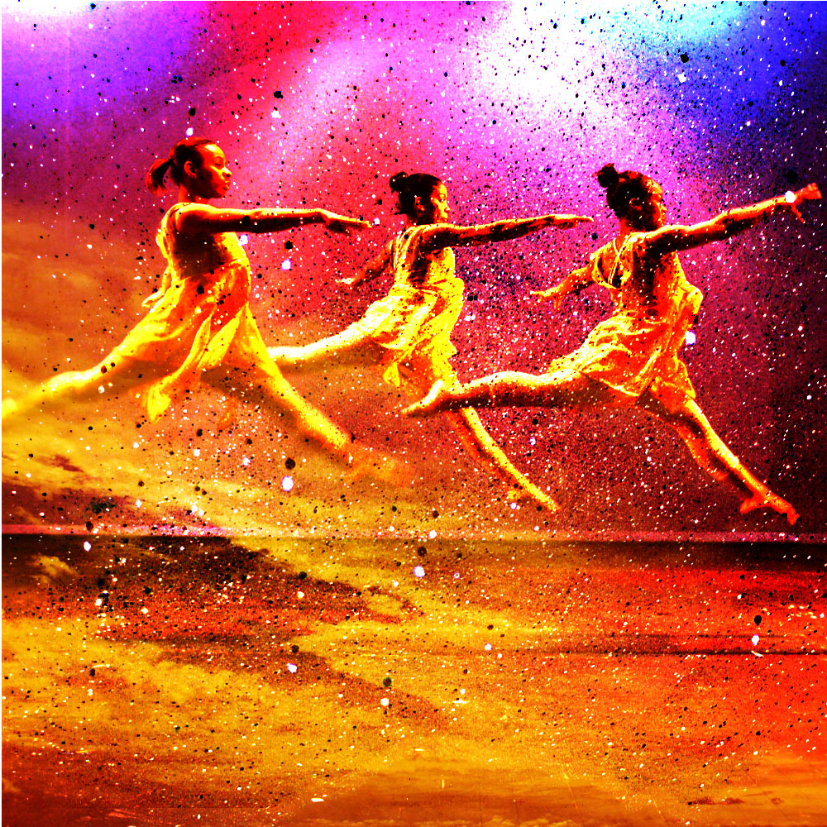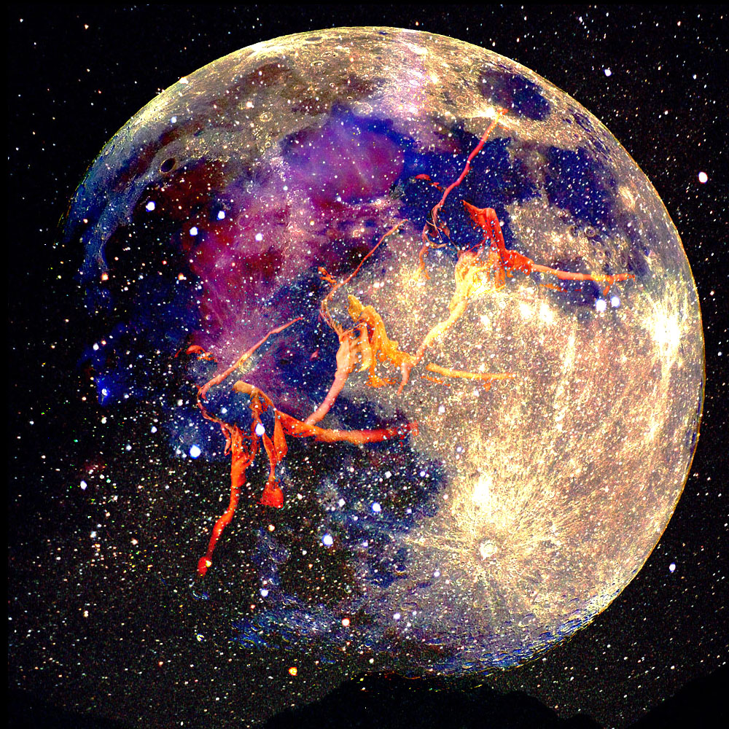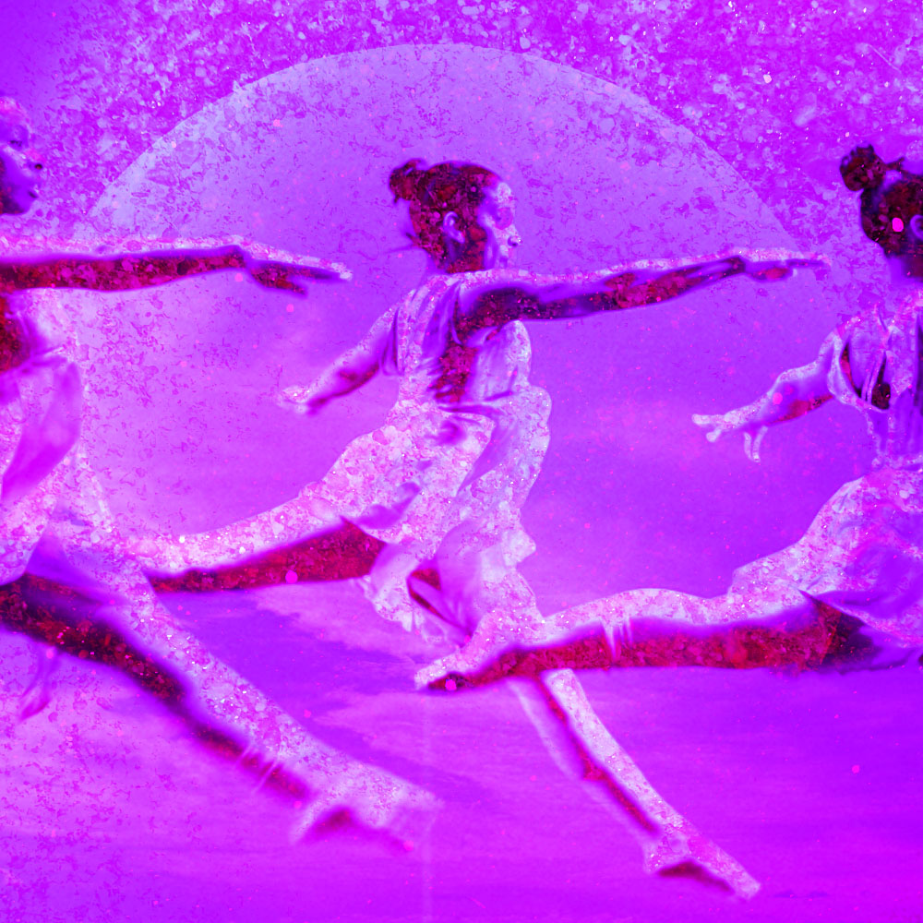

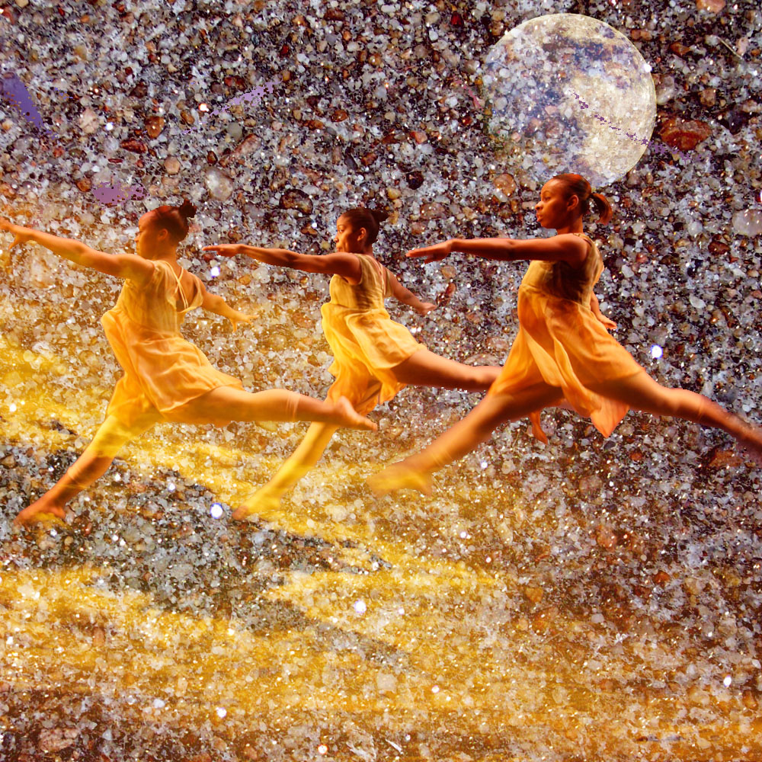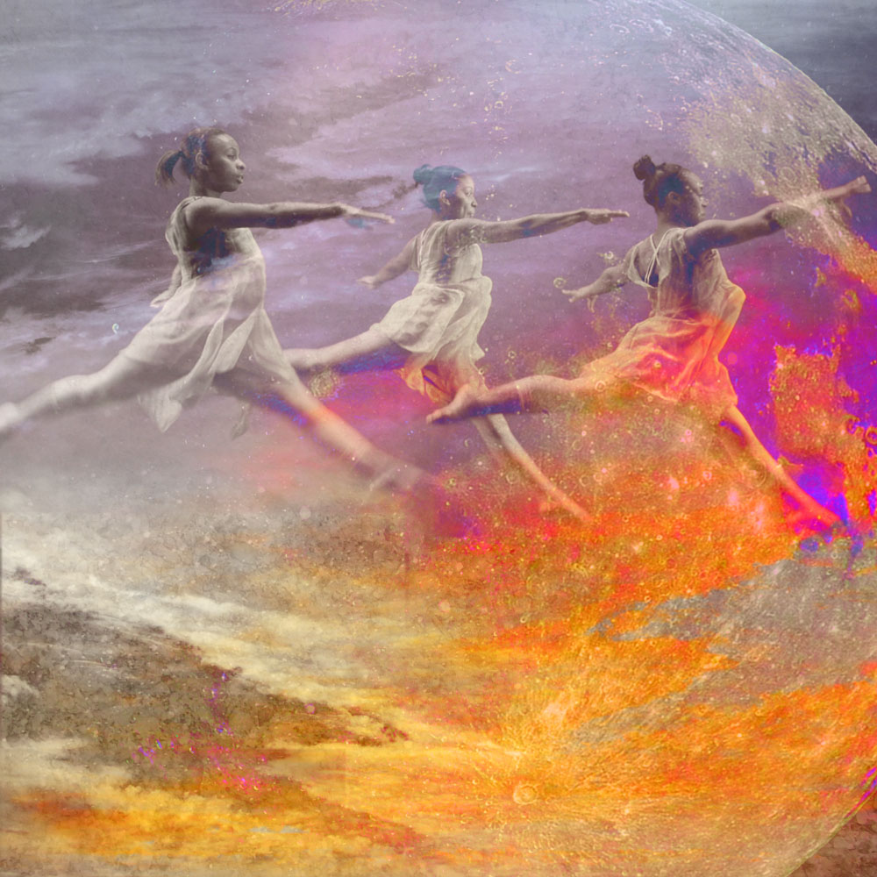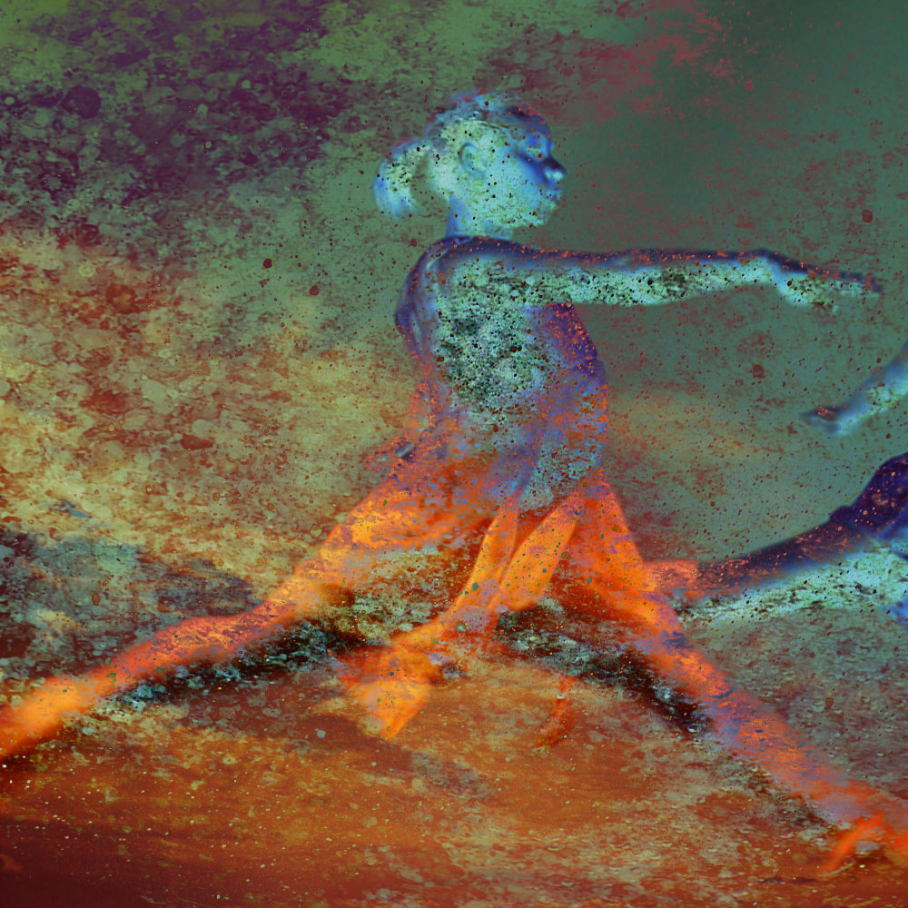

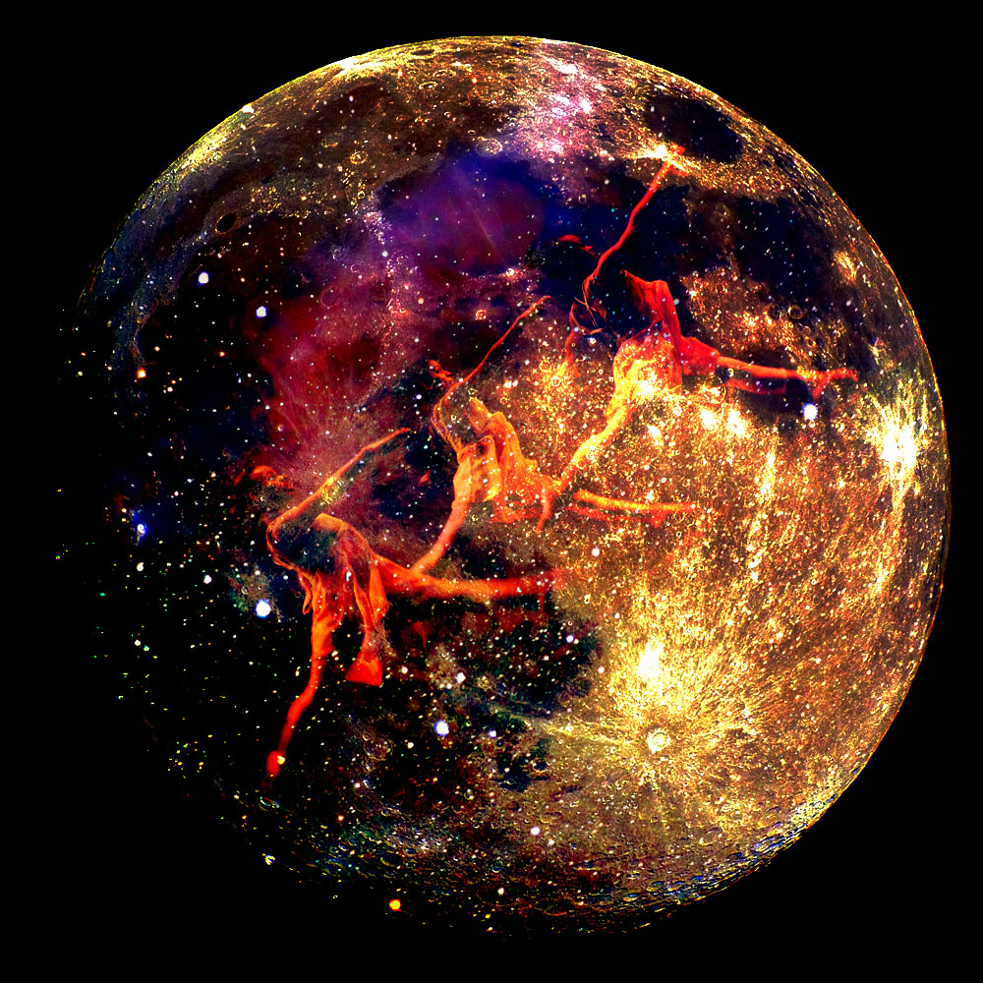
Use the information on the attached page to keep track of what you do for each layer.
Layer Blending Options
Check each mode used for each picture
 | 1 | 2 | 3 | 4 | 5 | 6
Normal
Dissolve
Darken
Multiply
Color Burn
Linear Burn
Darken Color
Lighten
Screen
Color Dodge
Linear Dodge(Add)
Linear Colour
Overlay
Soft Light
Hard Light
Vivid Light
Linear Light
Pin Light
Hard Mix
Difference
Exclusion
Subtract
Divide
Hue
Saturation
Color
Luminosity

